**Question 1**

1. Compare and Contract the messages conveyed in **Source 1** and **Source 2.**

(4 marks)

1. Evaluate the usefulness, in terms of strengths and weaknesses, of **Sources 1** and **2** as representations of popular European thought during the period of study. (5 marks)

1. Explain the historical context of **Source 3.**

(4 marks)

1. Identify and account for the author’s perspectives in **Sources 3** and **4** regarding political views within your period of study.

(6 marks)

1. Evaluate the extent to which the **four** **(4) Sources** give an accurate insight into political views within your period of study.

**Sources**

**Source 1:**

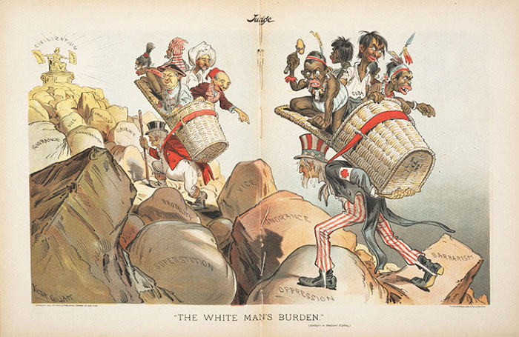

The “White Mans Burden (Apologies to Rudyard) by American cartoonist Victor Gillam was published in 1899 in the U.S Judge Magazine.

**Source 2:**

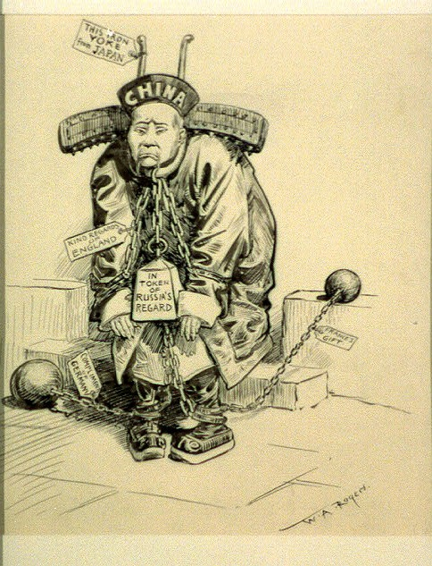

Above is the cartoon titled “Unprepared, doesn’t have to fight” which was produced by the American cartoonist William Rogers between 1900-1918. The man shown in the cartoon is wearing a Yoke and a ball and chain.

The tags on the iron yoke reads “***This iron yoke is from japan”, t***he tag on the chain reads ***"Kind regards of England,"*** The iron weight attached to the man reads ***“In token of Russia's regard,"*** the tag on the ball and chain reads ***"Compliments of Germany,"*** and the other tag on the ball and chain reads ***"France's gift."***

*(A Yoke is a wooden crosspiece that is fastened over the necks of two animals and attached to the plough or cart that they are to pull)*

**Source 3:**

[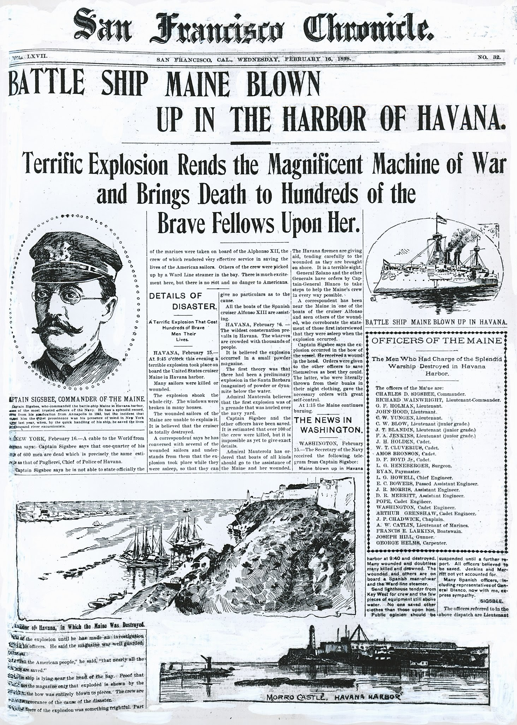](https://www.sfchronicle.com/news/article/Chronicle-Covers-When-a-war-started-on-the-front-6829390.php?utm_campaign=gplus-premium&utm_source=CMS%20Sharing%20Button&utm_medium=social#asset-photo-9347021)

The front page of American newspaper “The Chronicle” from Feb. 16, 1898.

**Source 4**:

**Disgraceful War-** British historian and professor Thomas Arnold in a letter to W. W. Hull, March 18, 1840

“This war with China . . . really seems to me so wicked as to be a national sin of the greatest possible magnitude, and it distresses me very deeply. Cannot anything be done by petition or otherwise to awaken men's minds to the dreadful guilt we are incurring? I really do not remember, in any history, of a war undertaken with such combined injustice and baseness. Ordinary wars of conquest are to me far less wicked, than to go to war in order to maintain smuggling, and that smuggling consisting in the introduction of a demoralizing drug, which the government of China wishes to keep out, and which we, for the lucre of gain, want to introduce by force; and in this quarrel are going to burn and slay in the pride of our supposed superiority”

*Simplified: This war with China really seems in my opinion to be so evil that the whole country is committing a sin by doing it and it makes me very upset. Can't people see how terrible this is and how guilty we will feel later? I do not remember any other war in history that has this combination of injustice and unsophistication (lack of civilization). Ordinary wars to conquer land are to me far less evil than to go to war in order to guarantee that we can keep smuggling a soul sucking drug, which the government of China wishes to keep out. We are forcing this drug on the Chinese people for money and in this conflict we are going to burn and kill (civilians) in the name of being superior.*